Tommy Walton

CS 500

Herron

3/16/2015

Project 2: BRDF and BVH

### Project Description

This project makes two additions to the original raycaster, a microfacet BRDF for more realistic lighting and a bounding volume hierarchy to speed up the runtime. The bounding volume hierarchy leverages an existing math library, Eigen, to construct a BVH out of axis aligned boxes. Each shape that inherits from shape class was given a BoundingBox() function that returns an Eigen axis aligned bounding box for that shape. The result was an almost 75x speedup for a scene with 73,389 triangles.

A microfacet BRDF was used to improve the lighting over Project 1. This implementation uses GGX (Trowbridge-Reitz) [1] for the specular distribution.

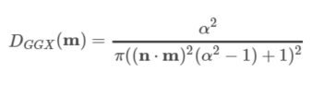

For the geometric shadowing term, this project uses Smith’s method [2] for breaking up the geometric shadowing into two components. Specifically, it uses Beckmann’s implementation [1] of Smith’s method.

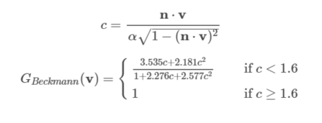

Finally for the Fresnel term this project uses the Schlick approximation [3].



The results can be seen in Figure 1, which demonstrates spheres with progressively increasing roughness parameters and Figure 2, which demonstrates shapes with a variety of roughness, diffuse, and specular values and two light sources.

### Figures

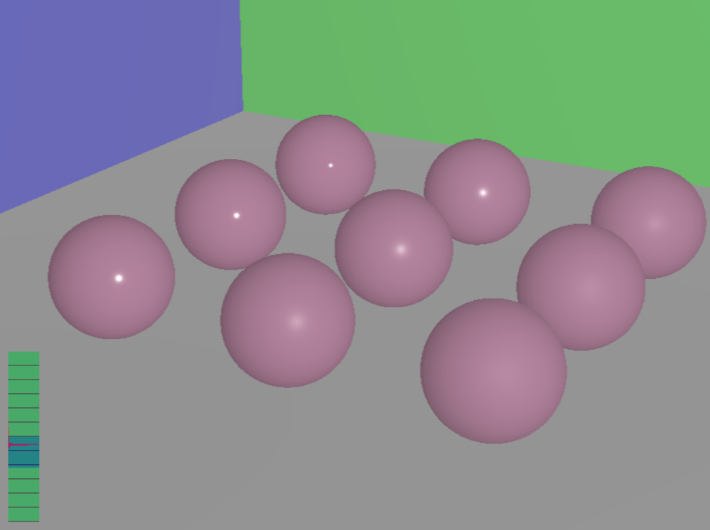

**Figure 1.**

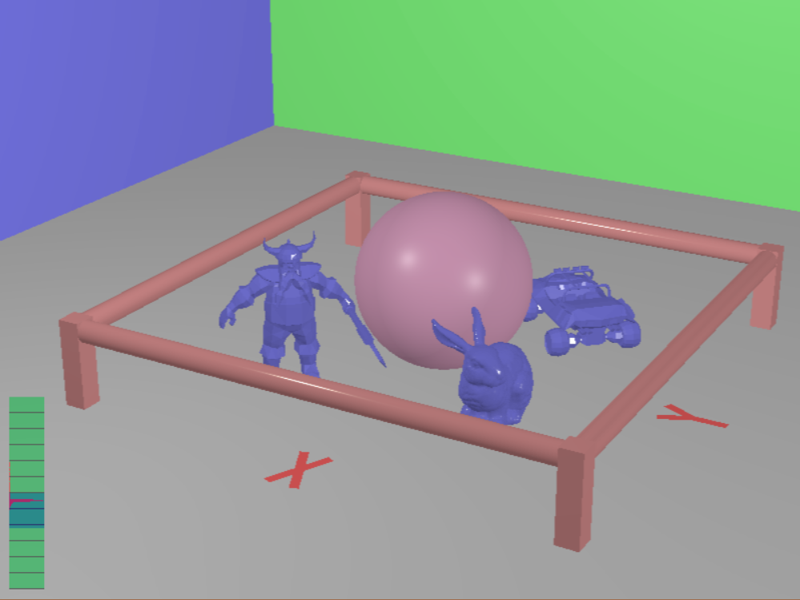

**Figure 2.**

### Metrics

Image Size: 800x600

Contents (pictured in Figure 2):

Spheres: 1

Boxes: 7

Cylinders: 4

Triangles: X – 4, Y – 6, Jeep – 2032, Dwarf – 1896, Bunny – 69451 = Total – 73389

Hardware: Surface Pro w/ Intel® Core™ i5-3317U CPU @ 1.70GHz

Time:

Without BVH: 615.087402 seconds

With BVH: 8.224086 seconds

615.087402 / 8.224086 = 74.790974x speedup

### Build and Run Instructions

The project was built using Visual Studio 2013. I modified the format of the scenetest.scn slightly. If a line in the .scn file starts with “disableBVH”, the raytracer will run without the BVH. The line for defining a light takes the same arguments as a brdf. This was done to enable re-using the same code for creating a regular object and a light. Otherwise, the project runs just like the original framework and can be run with run.bat.

References

[1] Walter et al. 2007, ["Microfacet models for refraction through rough surfaces"](http://www.cs.cornell.edu/~srm/publications/EGSR07-btdf.pdf)

[2] Blinn 1977, "Models of light reflection for computer synthesized pictures"  
[3] Schlick 1994, ["An Inexpensive BRDF Model for Physically-Based Rendering"](http://www.cs.virginia.edu/~jdl/bib/appearance/analytic%20models/schlick94b.pdf)